NSSLHA January General Meeting

Meeting Minutes

January 20, 2015

Opening
The NSSLHA officer meeting was called to order at 7:00 on January 20, 2015 by President, Katelyn Grizzle.

Present
President: Katelyn Grizzle, grizzlek@msu.edu
Vice President: Alex Powers, powersa9@msu.edu
Secretary: Jessica Prieskron, priesko6@msu.edu
Treasurer: Haley Farkas, farkash1@msu.edu
Community Service Chair: Lexy Barman, barmanal@msu.edu

Discussion
- Upcoming event this week
  - CSD Confab: Dr. Laura Dilley
    - January 22, 2015 from 2:30 PM – 3:30 PM in room 182 CAS
    - 1 point for attending, please email nsslha@msu.edu if you do attend
  - CSD Faculty Candidate Talk: Dr. Kathy Nagle
    - January 22, 2015 from 11 AM – 12 PM in room 182 CAS
- Polar Plunge
  - Polar Plunge is February 22 and our possible theme is “Hippie-thermia” Get it? ;)
  - If you have any other ideas, let us know
  - You pledge money to jump into a lake with pride and bare the cold, which benefits sending kids to the Special Olympics.
  - More information to come! Keep a look out.
  - 3 points for attending
- Dance Marathon
  - Dance Marathon is on April 11, 2015
  - Dance Marathon at Michigan State University is a student-run non-profit organization that raises both monetary support and awareness for the needs of children and young adults at The Cassie Hines Shoes Cancer Foundation and the Sparrow Children's Center.
  - Cassie Hines was a CSD student at MSU and passed away from cancer a few years ago.
  - We are trying to have a few DM members come and talk at our next meeting about registration details.
  - 3 points for attending
- Pizza with the Profs
  - Friday, February 13th at 12 PM in Oyer we will be having our Pizza with the Profs lunch date
  - Come hang out with the faculty and get some free pizza
- Upcoming Semester Fundraisers
  - We are having a fundraiser at Tropical Smoothie on Tuesday, February 3rd from 5 PM – 9 PM
    - You can earn up to 3 points (1 point for you & ½ point for every receipt after that)
  - T-shirt Fundraiser
    - We sent around an interest sheet at the meeting tonight about ordering CSD t-shirts.
    - T-shirts will be $10 each and the design will be posted to the NSSLHA Facebook page
    - We will collect money at the February meeting
- 2015 Oyer Lecture Series
  - This 25th Annual Oyer Lecture Series will be held on March 6, 2015 in Rm. 147 CAS
  - RSVP by February 27 at: http://comdis.msu.edu in the “Events” tab
  - 1 point per lecture
  - I have attached the flyer to the bottom of the minutes for more details and schedule information
- MSHA Conference 2015
  - The MSHA Conference this year will be held in Lansing at the Raddison Hotel on March 26-28
    - 111 N. Grand River, Lansing, MI 48933
  - An email will be sent out with more detail and how to register
  - Volunteers will be needed for the entire weekend and you will get points for volunteering
  - The undergraduate roundtable session will be on Friday, March 27. This will entail resume help, application advice, graduate school information followed by a Q & A session
  - This will be a very valuable event – so mark the date!
  - More information can be found online at: http://www.michiganspeechhearing.org/annual_conference.php
- Lunch with the Professors
  - This is an opportunity to get to know the CSD Faculty a little better. We know this has been difficult with the switch to online classes. Sheets were passed around at the meeting with all of the professors and a brief bio about their areas of specialty. We will tally up the results and compile a list of time and dates that specific professors are available to meet up.
  - Look for more information in your email!
- Resume Workshops
  - Friday, January 23 from 1 PM – 2 PM in the International Center, Rm. 115
  - Monday, January 26 from 10 AM – 12 PM and Tuesday, January 27 from 1 PM – 3 PM, both in Student Services Building, Rm. 113
  - Bring a copy of your resume to receive a quick one-on-one resume critique.
- GRE Preparation
  - Check Kaplan or Princeton sites for FREE online and in-person practice GRE Exams
  - There are upcoming practice exams February 1 & February 3 through Kaplan
- Employment & Volunteer Opportunities
  - Lexy presented the chapter with many great employment and job opportunities! Please reference the Power Point presentation attached to the email for additional details.
- Elections
  - Elections will be next month!
  - If you are interested in running please email a quick application to nsslha@msu.edu answering the following questions:
    - Position running for in the subject line
    - Include your name, year, major and expected graduation date
    - Why you are interested in this position?
    - Why you are a good fit for the position?
    - Any changes or ideas you have for next year’s NSSLHA.
  - The following positions are open and their descriptions are as follows:
    - Vice President:
      - Assists President in emails and communication with professors and speakers
      - Reserves room and meeting location through Oyer (Main office) and Com Arts (Marge Barkman)
      - Maintains NSSLHA Facebook page, twitter, website, etc.
      - Maintains CAS membership bulletin board
      - Facilitates communication among officers and members
    - Secretary:
      - Takes minutes at each NSSLHA meeting and sends them out to NSSLHA members
      - Records membership points
      - Creates and prints NSSLHA active membership certificates
      - Maintains and responds to email
    - Treasurer:
      - Checks NSSLHA mailbox in Oyer regularly
      - Collects membership dues and deposits it into the NSSLHA account at the Administration building
      - Maintains the bank account
      - Handles reimbursements for club activities/purchases
    - Fundraising Chair:
      - Assists the Treasurer with any additional tasks or programming
      - Plan at least 2 successful fundraisers throughout the year
      - Advertises and promotes the fundraisers in the CSD department, school of CAS, and MSU campus/community
    - Community Service Chair:
      - Provide NSSLHA members with opportunities to receive points for membership by getting involved with the local community.
      - Talks to local schools, hospitals, nursing homes, etc. to discover opportunities to help
      - Collects attendance at every activity to give secretary list of names and points to record
      - Plans the Teddy Bear Picnic with the help of other board members; set up and organize the SLP panel event
    - Things to keep in mind:
      - This is a growing club, and with that, you will have to create new and more opportunities for members
      - There is an additional time commitment
      - This is an awesome resume builder
      - It is lots of fun and gets you more involved with the chapter, department and faculty!
- Guest speaker
  - Teresa Lyden from the University of Michigan Hospital in Ann Arbor, Michigan had an awesome presentation on her clinical experiences in the field; specifically head and neck cancer rehabilitation.
  - If you would like to contact her please do so at lyden@umich.edu.

Social Media
Be sure to keep up with the website (www.msunsslha.weebly.com)
Join our Facebook group (https://www.facebook.com/groups/732485650111216/)
Or email us at nsslha@msu.edu
Follow us on Twitter @MSU_NSSLHA, https://twitter.com/MSU_NSSLHA

Adjournment
Meeting was adjourned at 8 PM. The next general meeting will be at 7 PM on February 17, 2015, room 148 CAS
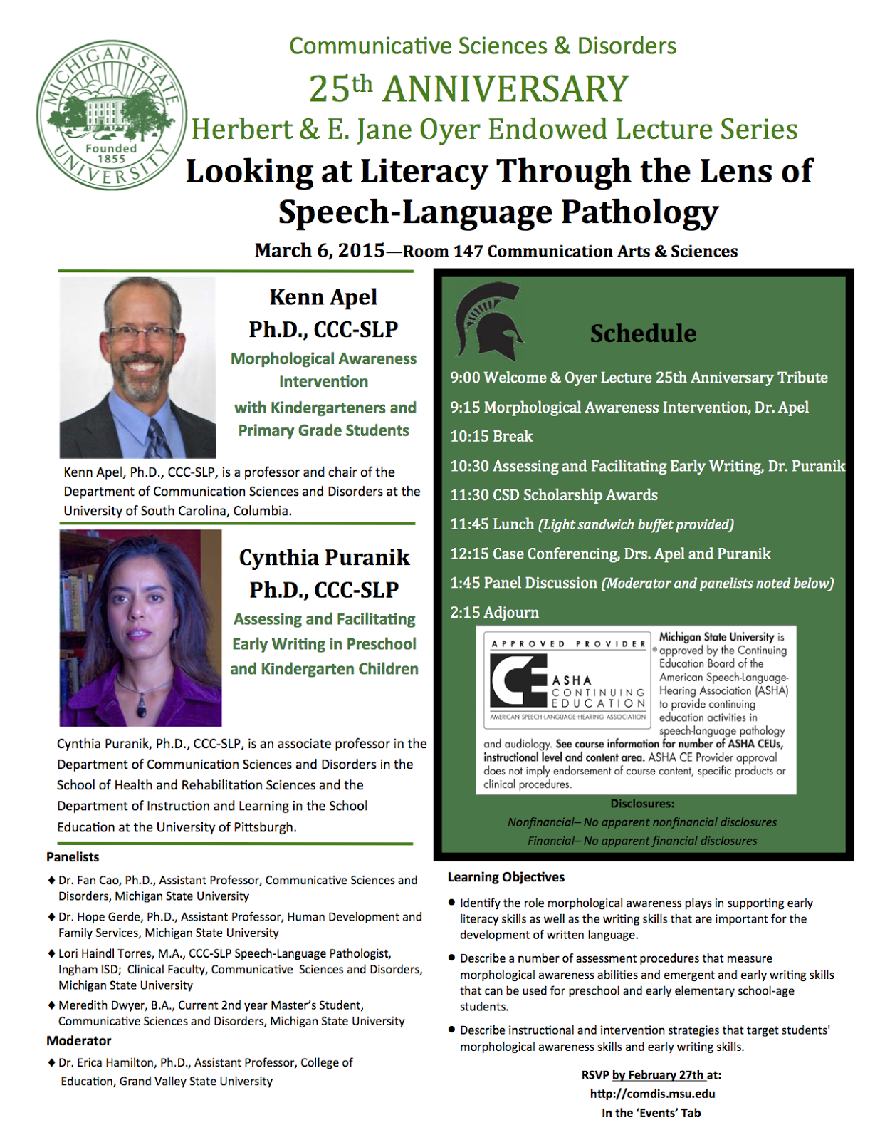
Minutes submitted by: Jessica Prieskorn

